TRAVEL & TOURISM BOOKING DATA ANALYSIS
USING SQL AND POWER BI

EXECUTIVE SUMMARY
This project delivers a comprehensive data analytics solution for the Travel and Tourism domain by integrating Excel, MySQL, and Power BI. The primary objective is to convert raw booking data into meaningful business insights through structured data cleaning, SQL-based transformation, statistical analysis, and interactive dashboard development. A cleaned SQL view was directly connected to Power BI using the MySQL Connector, ensuring data integrity and real-time analytical capability. The results support informed decision-making related to revenue optimization, destination performance, seasonality, and customer behavior.
INTRODUCTION
The travel and tourism industry generates large volumes of transactional and customer data across destinations, seasons, and booking channels. Analyzing this data effectively is critical for understanding demand patterns, improving operational efficiency, and enhancing customer experience.
This project demonstrates an end-to-end analytics workflow using structured query language (SQL) and business intelligence tools. The focus is on building a clean data pipeline and deriving actionable insights through visualization and analytical reporting.
OBJECTIVES
The primary objectives of this project are:
- To clean and standardize raw travel booking data
- To perform data transformation and validation using SQL
- To prepare an analysis-ready dataset through SQL views
- To conduct descriptive statistical analysis
- To develop DAX-based KPIs in Power BI
- To design a professional, interactive dashboard
- To generate insights and business-oriented recommendations

DATASET DESCRIPTION
The dataset used in this study represents synthetic Travel & Tourism booking records and includes:
- Customer demographics : age, gender, country.
- Travel details : destination, travel type, season, trip duration.
- Booking attributes : booking channel, payment mode, booking date.
- Revenue-related information : total revenue, number of travellers.
The dataset was initially available in Excel format and later processed using MySQL for analytical readiness.
METHODOLOGY
A structured methodology was adopted to ensure data accuracy, consistency, and analytical reliability.
Data Cleaning and Transformation (Excel & SQL):
- Preliminary data inspection and basic formatting were performed in Excel
- Missing, invalid, and inconsistent values were identified
- Duplicate and irrelevant records were removed using SQL
- Text fields were standardized and numeric ranges validated
- Logical consistency of travel dates was ensured
- A derived metric, Revenue per Traveller, was created using SQL
These steps ensured a clean and reliable dataset for analysis.

SQL Processing:
The cleaned dataset was imported into a MySQL database, where SQL was used to:
- Create database tables and schemas
- Apply filtering, aggregation, and validation rules
- Generate analytical summaries
- Create a final SQL view named clean_bookings
This view served as the single source of truth for reporting.

Statistical Analysis:
Descriptive statistical techniques were applied using SQL to examine:
- Average, minimum, and maximum revenue
- Average trip duration
- Seasonal and destination-based booking distribution
- Revenue contribution by booking channel
The analysis helped identify key trends, variations, and performance drivers.

Power BI Integration:
Power BI was directly connected to the MySQL database using the MySQL Connector.
The clean_bookings SQL view was imported without intermediate data duplication, ensuring:
- Data accuracy and consistency
- Clear separation between backend processing and frontend analytics
- Ease of data refresh and scalability

DAX Measures and KPIs:
Custom DAX measures were created to support dynamic analysis, including:
- Total Revenue
- Total Bookings
- Average Revenue
- Revenue per Traveller
- Average Trip Duration
Standard DAX functions such as SUM, AVERAGE, COUNT, DISTINCTCOUNT, CALCULATE and IF were applied to implement business logic.
Dashboard Development:
An interactive Power clear and logical layout, incorporating:
- KPI cards for key performance indicators
- Bar and column charts for comparative BI dashboard was designed with a analysis
- Line charts for trend identification
- Pie and donut charts for categorical distribution
- Slicers and filters for user-driven exploration
The dashboard enables stakeholders to interpret data efficiently and make informed decisions.

Diagram
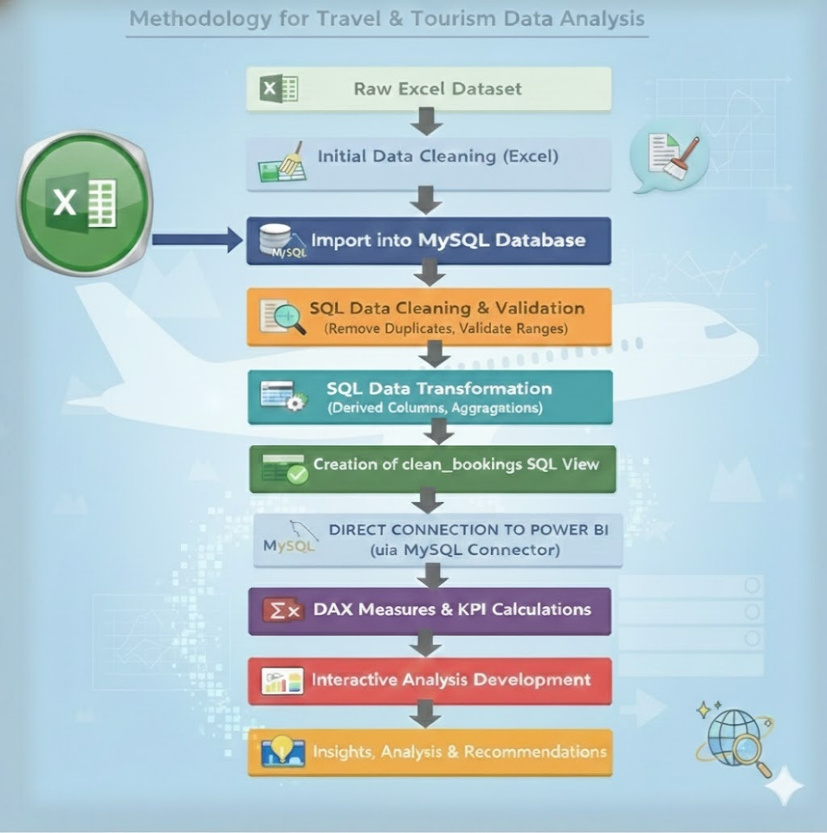

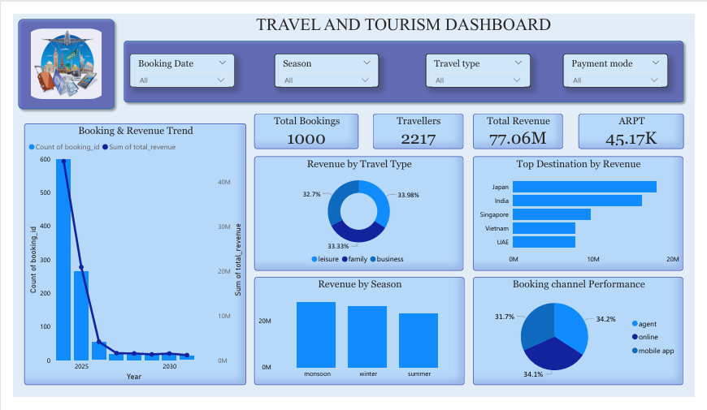
Dashboard

INSIGHTS AND ANALYSIS
The Travel and Tourism booking analysis is based on 1,000 total bookings involving 2,217 travelers, resulting in an average of 2.2 travelers per booking. This indicates a strong dominance of group and family travel, which positively impacts overall revenue generation.
The business generated a total revenue of 77.06 million, with an Average Revenue per Traveler (ARPT) of 45.17K, reflecting a healthy pricing structure and effective revenue realization per booking.
Booking and Revenue Trends
Trend analysis shows that booking volumes were significantly higher during earlier periods, followed by a sharp decline in later years. Revenue follows the same downward trajectory, indicating a direct correlation between booking volume and revenue. This suggests that recent revenue reduction is primarily demand-driven rather than due to pricing inefficiencies.

Travel Type Performance
Leisure travel contributes the highest share of total revenue, followed by family travel, while business travel contributes the least. This highlights leisure travelers as the primary revenue-driving segment, supported by longer stays and higher discretionary spending.
Destination-wise Revenue Distribution
Destination analysis identifies Japan as the top revenue-generating destination, followed by India and Singapore. These destinations together contribute a substantial portion of total revenue, indicating strong customer preference and higher spending patterns. Other destinations such as Vietnam and the UAE show comparatively lower revenue contribution.
Seasonal Revenue Patterns
Seasonal analysis reveals that the summer season generates the highest revenue, closely followed by winter, while monsoon records the lowest revenue contribution. This confirms the presence of strong seasonality effects on travel demand and booking behavior.
Booking Channel Performance
Revenue is well distributed across booking channels, with digital platforms (app and website) slightly outperforming offline bookings. This demonstrates increasing customer adoption of online booking channels due to convenience and accessibility.
Overall, the insights confirm that destination preference, seasonality, travel type, and booking channel selection are the key drivers influencing revenue and booking performance.
RECOMMENDATIONS
Based on the above insights and observed metrics, the following recommendations are proposed:
Strengthen Digital Channels
Since online platforms contribute a higher share of bookings and revenue, improving app and website user experience can further increase conversion rates and total revenue.
Focus on High-Revenue Destinations
Destinations such as Japan, India, and Singapore should receive priority in marketing investments, as they contribute significantly to the 77.06M total revenue.
Address Booking Decline Trends
The sharp decline in bookings directly impacts revenue. Targeted promotions, early-bird offers, and seasonal campaigns should be introduced to revive demand.

Promote Group and Family Packages
With an average of 2.2 travelers per booking, customized group and family packages can further increase revenue per trip.
Improve Off-Season Performance
Since monsoon season records the lowest revenue, special discounts, flexible booking policies, and bundled offers should be introduced to improve seasonal balance.
TOOLS AND TECHNOLOGIES USED
- Microsoft Excel – Initial data inspection and cleaning
- MySQL – Data cleaning, transformation, Aggregation, validation, derived metrics and analysis
- MySQL Connector – SQL–Power BI integration.
- Power BI – Visualization, DAX, dashboarding.
CONCLUSION
This project successfully demonstrates an end-to-end data analytics approach for the Travel and Tourism sector using SQL and Power BI. By cleaning and transforming raw booking data in MySQL and integrating it directly with Power BI through the MySQL Connector, a reliable and analysis-ready dataset was established.
The analysis highlights how revenue and bookings are strongly influenced by travel type, destination preference, seasonality, and booking channels. Metrics such as Total Revenue, Total Bookings, Average Revenue per Traveler (ARPT), and Average Trip Duration provided clear measurement of business performance. The interactive dashboard enabled effective visualization of trends, comparisons, and patterns, supporting data-driven interpretation.
Overall, the project shows that structured data processing combined with business intelligence tools can convert raw transactional data into meaningful insights. The findings can support better planning, targeted marketing, and informed decision-making in the travel and tourism industry.

